ELCT 302
Laboratory Report #1
Open-Loop Control & Obtaining Feedback
Group #2B (Steering Control)
September 30th, 2023

I hereby certify that I have complied
with the Spirit and the Letter
of the Carolinian Creed
in preparing this report

Mady Hines
Mady Hines

Jacon Vaught
Jacob Vaught

Department of Electrical Engineering
University of South Carolina
Columbia, SC 29208

Abstract
This project focuses on the design and implementation of a steering system of an electric autonomous car. It utilizes the principles of resonance, amplification, and rectification. The main objectives include developing a servo-position motor control system for steering and a steering system with feedback sensors. The steering system is designed to operate within a voltage range of 4.8V to 6V, communicate at a frequency of 50Hz, and have a servo rotational range of 180⁰. The feedback uses an LC circuit which has a specified inductance at 20kHz.
Table of Contents
Table of Figures……...…………………………………………………………………………...3
I Introduction 4
A. Background 4
B. Steering System: Resonance, Amplification, and Rectification 4
C. Steering: Servo-Position Control 4
II Theory 5
A. Open-Loop Control 5
B. Pulse Width Modulated Signals 5
C. Servo Power Regulation 6
D. Diode 7
E. Operational Amplifier (Op-Amp) 8
F. Feedback Sensor 9
III Experimental or Procedure 10
A. Open-Loop Control 10
B. Distance Measurement 11
IV Discussion / Results 12
A. Open-Loop Control 12
B. Distance Measurement 12
V Conclusions 13
A. Open-Loop Control 14
B. Feedback Sensor and Distance Measurement 14
C. Future Work and Recommendations 14
D. Overall Takeaways 14
VI Appendix 14
A. Resistance Table 14
VII References 14

Table of Figures
Figure 1 – Open-Loop Control Block Diagram…5
Figure 2 - Servo Position Representation…7
Figure 3 - LM324 Op-Amp Schematic…9
Figure 4 – Steering Hardware Schematic divided into sub-circuits…10
Figure 5 - Graph of the Distance of Car to Center of Track vs OUTPUT DEFFERENCE of each sensor…13

Laboratory 1: Open-Loop Control & Obtaining Feedback

Introduction

Background
This lab focuses on developing a steering system for an electric autonomous vehicle. The main objectives include the design and implementation of a steering system and to establish servo-position control for steering. The concepts used to complete these objectives stem from the history of autonomous vehicle steering systems which is relatively recent. It began in the 20th century and progressed in the following order: early robotics and automation, electronics advancements, sensor development, resonance and amplification concepts, advancements in robotics research, emergence of self-driving cars, and ongoing academic and industry research. In each of these broad topics, more specific concepts formed. Early robotics and automation mainly focused on basic tasks and lacked sophisticated sensors and control systems. However, transistors, integrated circuits, and microcontrollers were later introduced for more precise control. Then sensors such as encoders, gyroscopes, and accelerometers were developed which improved control accuracy even more. This allowed vehicles to sense their position and movement to improve steering control. The use of resonance and amplification principles in autonomous steering systems were introduced to improve the precision and responsiveness of steering mechanisms. All these developments are useful in the design of this project.

Steering System: Resonance, Amplification, and Rectification
In this lab, we create a steering system using the fundamental concepts of resonance, amplification, and rectification. These principles are crucial in designing and implementing a precise and efficient steering system. Resonance is used for track recognition in which we use sensors to detect track features at specific frequencies. This allows the vehicle to precisely identify its position on the track and adjust for optimal navigation and speed. Amplification is essential for high-speed precision control. It can amplify the control signals to ensure rapid and precise changes in direction. Rectification is crucial in maintaining a smooth and consistent racing line. The vehicle’s control algorithms can rectify sensor data to eliminate deviations for the car to follow the correct trajectory path. Lastly, using feedback control systems is important for the vehicle to continuously adjust the steering and speed based on real-time sensor data.

Steering: Servo-Position Control
Servo-position control is used for steering in the electric autonomous car. It is a complex and highly integrated system which combines precise control algorithms, feedback sensors, safety features, and dynamic adjustments. This helps achieve precise and reliable steering to navigate tracks efficiently. The core of the steering system is the servo motor which physically turns the front wheels. Feedback sensors are another important aspect of the steering system to achieve accurate steering. These provide real-time feedback on the position and wheel orientation.

Theory

Open-Loop Control
Unlike a closed-loop control system, an open-loop control system is not based on feedback from the output to adjust the input. The input is predetermined and is not affected by the system’s actual performance. It relies on the system’s expected behavior and mathematical models. Due to it not having a feedback loop, the control action is not based on real-time feedback and cannot measure the system’s output to compare it to the desired reference value. Open-loop control systems do not require sensors or complex control algorithms making it a simple design [1]. As shown in Figure 1 below, it consists of an input signal, controller, plant/system, and output response. A couple examples of open-loop control systems include toasters and traffic signals. For example, a toaster is set to a desired toasting level and operates for a fixed duration, regardless of the actual browning of the bread. Similarly, a traffic signal’s timing is based on predetermined patterns and schedules. It is not affected by actual traffic conditions. In this lab, open-loop control is used to complete the first task. The regulation circuit implements an open-loop control system to power the servo motor.
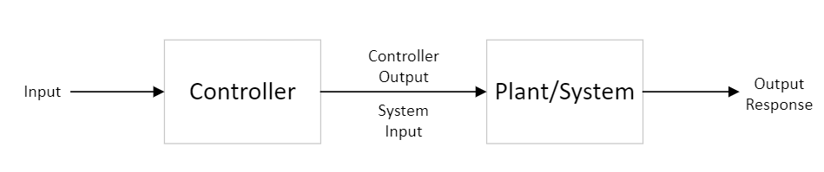
Figure 1. Open-Loop Control Block Diagram

Pulse Width Modulated Signals
Pulse width modulation, also referred to as PWM, is widely used in electronics and control systems. It controls the average voltage or power delivered to a load by varying the duty cycle of a periodic waveform. PWM signals represent analog information using a digital signal. It works by rapidly switching from high voltage (“on” state) to low voltage (“off” state). The ratio of “on” time to the total period determines the average voltage delivered to the load. The characteristics of PWM signals include periodic waveform, duty cycle, frequency, and amplitude. It is periodic because the signals repeat over time with a consistent period. The period determines how often the waveform repeats and is denoted as T. Duty cycle is an important characteristic because it is the fraction of time during one period that the signal is high (in the “on” state). The longer the “on” time, the higher the duty cycle. It is typically expressed as a percentage or decimal and is denoted as D. The frequency of a PWM signal is the reciprocal of the period. It is typically measured in Hz and is denoted as f. It defines how many times the PWM waveform cycles per second. The amplitude is typically constant, the average voltage or power delivered is controlled by varying the duty cycle [2]. The relationships of these characteristics are shown the Equations 1, 2, and 3 below. PWM has many advantages such as efficiency (from minimizing power losses in the switching process), analog control, noise reduction (from electromagnetic interference and audible noise), and versatility. These signals are used in motor control, voltage regulation, and temperature control. In this project, PWM signals are used in the open-loop control system which regulates energy flow.
$D=\frac{T_{on}}{T}$ Equation 1
$$Average Voltage\left(V_{low}=0V\right)$$
$⟹ -V_{a}=D⋅\left(V_{high}-V_{low}\right)$ Equation 2
$T=\frac{1}{f}$ Equation 3

Servo Power Regulation
Servos are electromechanical devices designed to provide precise control over the position of a mechanical component. There are four main methods of servo power regulation including linear voltage regulators, switching voltage regulators, current limiting, and filters and capacitors. Linear voltage regulators provide a stable output voltage, but if there is a significant difference between the input and output voltage then it becomes less efficient. Switching voltage regulators use a switching transistor to regulate the output voltage and are more efficient, especially for applications with varying input voltages. Current limiting typically consists of current-sensing circuitry that monitors the current drawn by the servo motor so it can adjust the power supply to prevent overcurrent conditions. Filters and capacitors are used to reduce electrical noise and provide additional stability in the power supply. Servo power regulation is important because it provides precise and accurate control over position and motion, maintains stable power supply to ensure consistency, protects the servo motor from voltage spikes and current surges, and reduces noise. Both voltage and current affect the performance of the servo motor. Voltage primarily affects motor speed, torque, motor efficiency, and motor life. Whereas, current affects motor protection, safety and fault detection, dynamic response of the motor, and current feedback for control [3].
This is relevant to this project to control the servo motor on the vehicle. The servo motor receives power from the voltage regulator and PWM signal from the microcontroller. The power requirements include full range of the servo motor. The servo duty cycle in relation to position follows accordingly: the duty cycle will approximately be 7.5%, when servo is centered, the duty cycle will approximately be 5% when fully left, and the duty cycle will approximately be 10% when fully right. Figure 2, from the laboratory worksheet, shows the position of the servo motor in relation to time.
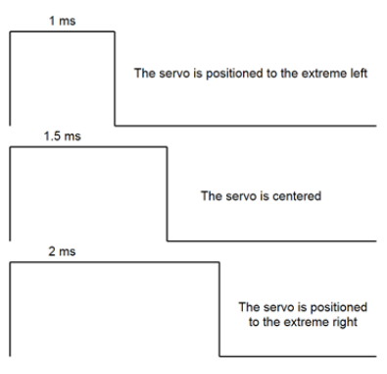
Figure 2. Servo Position Representation

Diode
Diodes are known for their ability to control the flow of electric current by only allowing it to flow in one direction. They consist of two regions: p-type semiconductor, also known as anode, and n-type semiconductor, also known as cathode. The anode region contains an excess of positively charged holes, while the cathode region contains an excess of negatively charged electrons. The junction between these two regions in known as the P-N junction. The diode’s operation is based on the behavior of these charge carriers. Two main principles are forward bias and reverse bias. Forward bias allows current to pass through with low resistance and occurs when a positive voltage is applied to the anode and negative voltage to the cathode. This creates an electric field allowing the flow of electrons from the N-region to the P-region. Reverse bias has high resistance which blocks the flow of current. This occurs when positive voltage is applied to the cathode and negative voltage to the anode causing an electric field that opposes the movement of charge carriers. A diode is typically modeled using an ideal model. The main properties of an ideal diode model include forward voltage drop (Vf), reverse breakdown voltage (Vr), forward bias current (If), and reverse bias current (Ir). Thermal dissipation can be a concern in diodes due to either forward voltage drop, high current applications, or reverse bias current. Forward voltage drop for silicon diodes occur at about 0.7V. There are several types of diodes, some include: rectifier diodes, Zener diodes, light-emitting diodes (LEDs), Schottky diodes, and varactor diodes (varicaps) [4]. The two diodes implemented in the design of the steering hardware are the rectifier diode and Zener diode. The Zener diode was just temporarily used as circuitry protection during testing before the microcontroller was implemented. However, the rectifier diode was needed in the magnetic distance sensors to prevent the peak detection low pass filter’s current from flowing back into the op-amp. The magnetic distance sensor schematic, from the laboratory worksheet, is shown in Figure 3.

Operational Amplifier (Op-Amp)
Operational amplifier’s core principle is to amplify the voltage difference between its inverting and non-inverting inputs, thus making the differential voltage as close to zero as possible. This is referred to as the virtual short-circuit condition. Ideal op-amp’s operate in linear, active mode and consist of the following characteristics: infinite open-loop Gain (A), infinite input impedance, zero output impedance, infinite bandwidth, and zero input offset voltage. However, real-life applications of op-amps have the following characteristics: different levels of voltage gain, high but finite input impedance, low but non-zero output impedance, slew rate, and small but non-zero input offset voltage and current. Common configurations of op-amps include inverting, non-inverting, and differential amplifiers. The fundamental op-amp is a multiterminal device consisting of the following terminals: inverting input (-), non-inverting input (+), output (OUT), power supply terminals (V+ and V-), and ground (GND). The LM324 amplifier was used in the lab, and the schematic is shown in Figure 3. Some common applications of op-amps are amplification, signal conditioning, oscillation, comparators, feedback control systems, and filters [5].
The magnetic distance sensor designed in this lab uses non-inverting amplifiers for the feedback control system. The voltage gain equation of the op-amp used for this lab is in Equation 4. However, this has its limitations because the equation is based on an ideal op-amp.
$-V_{o}=V_{in}\left(1+\frac{R_{2}}{R_{1}}\right)$ Equation 4
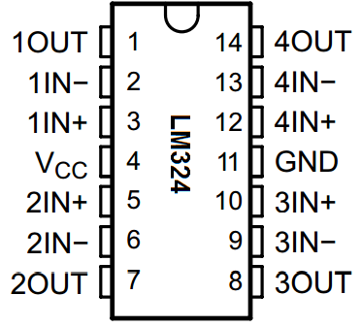
Figure 3. LM324 Op-Amp Schematic

Feedback Sensor
Feedback sensors are very important because they measure specific physical quantities and send feedback signals to controllers, enabling closed-loop control. Some key principles of feedback sensors include transduction, accuracy, resolution, and sensitivity. In this lab, the feedback sensors use transduction to convert the position of the vehicle into electrical signals that can be easily processed and analyzed [6].
There are four main stages of the feedback sensor: LC resonate circuit, amplification circuit, rectification circuit, and peak low pass filter. The LC resonate circuit contains an inductor and capacitor in parallel which oscillates at its natural resonant frequency. The inductor converts the track’s magnetic field, which is produced from current pulses carrying a 20 kHz square wave signal, into voltage pulses. The voltage increases as the inductor gets closer to the track. This sub-circuit generates at a certain frequency and can pick out a signal at a particular frequency from a complex signal. The resonance frequency formula is shown in Equation 5.
The amplification circuit contains a non-inverting op-amp and two resistors. As stated in the ‘Operational Amplifier (Op-Amp)’ section above, the op-amp’s output voltage is multiplied by a high gain and the difference of the voltage at the non-inverting terminal from the voltage at the inverting terminal. This formula was presented above in Equation 4.
The rectification circuit just consists of a diode as mentioned in the ‘Diode’ section above. It conducts current in one direction from the amplification circuit to the peak low pass filter and prevents the current from flowing back into the amplification circuit from the peak low pass filter. The diode does not turn on until the source voltage reaches about 0.7V which then means the output voltage is 0.7V lower than the source voltage.
The peak detection low pass filter consists of a capacitor and resistor in parallel with one another. The main purpose of this filter is to hold the op-amp output’s peak value to produce a DC signal. There is also a Zener diode in parallel with the peak detection low pass filter as a safety measure. It only allows current to flow in one direction, allowing the capacitor to quickly charge up, but slowly discharge through the resistor. The values of these components were chosen so the output does not “ripple,” but will still change as the vehicle’s position changes. The ripple should be less than 5% because it will produce a bigger time constant (output delay) if the ripple is small. Thes values were determined by Equations 6 through 11. Step 1 used Equation 6 to choose the voltage ripple. Step 2 used Equations 7, 8, and 9 to find time (t). Step 3 used Equations 10 and 11 to find C and R. The magnetic distance sensor schematic, from the laboratory worksheet, is shown in Figure 4.
$f=\frac{1}{2π\sqrt{L_{1}C_{1}}}$ Equation 5
$V_{ripple}=V_{p}-V_{cmin}$ Equation 6
$V_{cmin}=V_{p}⋅sinΘ$ Equation 7
$t^{''}=T⋅\frac{Θ}{{360}^{∘}}$ Equation 8
$t=t^{'}+t^{''}$ Equation 9
$V_{c}=V_{p}⋅e^{\left(-\frac{t}{R⋅C}\right)}$ Equation 10
$V_{c}=V_{cmin}$ Equation 11
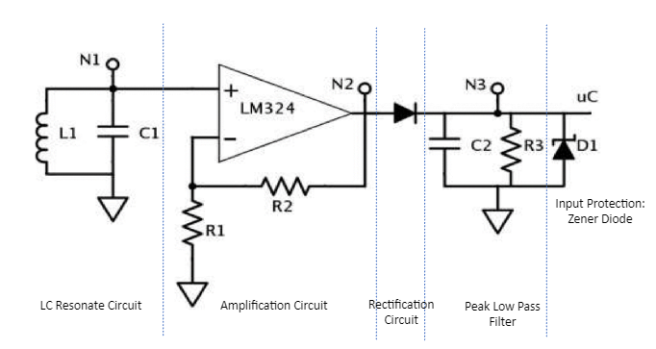
Figure 4. Steering Hardware Schematic divided into sub-circuits.

Experimental or Procedure

Open-Loop Control
The first set of tasks pertains to open-loop control, which involves regulating the power supplied to a servo motor and ensures accurate control through voltage division and code implementation. First, we designed a regulation circuit for the servo motor. This circuit must guarantee that the servo motor operates within its specified voltage range of 4.8V to 6V, providing a stable and regulated power supply.
Next, we designed a voltage divider circuit. This circuit's purpose is to generate an output voltage that spans the range of 0 to 3.3V, serving as a crucial component in subsequent steps. To complement this, a specific code must be written to read the output voltage of the voltage divider as an analog-to-digital converter (ADC) number. This code should calculate the ratio of this voltage to the desired maximum voltage (3.3V) and utilize this ratio as the pulse-width modulation (PWM) duty cycle. Upon completing the code development, it should be uploaded to the microcontroller, and its functionality should be rigorously verified. The microcontroller should accurately read the voltage, perform the duty cycle calculations, and effectively control the servo motor, aligning its position as intended.
Finally, the servo motor should be connected to the microcontroller, establishing secure and compliant connections following the datasheet's recommendations. Subsequently, the servo motor's behavior should be observed and tested to ensure that it responds appropriately to the control signals, thereby verifying the full range of motion from 0⁰ to 180⁰.

Distance Measurement
The second task relates to distance measurement. First, it is imperative to research and gather datasheets for all components integral to the distance measurement circuitry. This step ensures a comprehensive understanding of each component's specifications, ratings, and operational principles. Following this, we constructed the distance measurement circuit. The power supply (VCC) should have a 1 Amp current limit.
The generation of a square wave gate signal using a function generator is the next key step. The gate signal should have a high side greater than the threshold voltage and a low side at a common voltage, all while maintaining a frequency of 20 kHz. We captured signal screenshots at key points in the circuit, specifically at N1, N2, and N3, is advised to visualize signal behavior and waveforms. These are in Figures 6, 7, and 8 in the appendix section. The signal seen at the non-inverting input of the LM324 appears as a sine wave, contrary to the expected square wave from the track signal.
To capture the distance measurements effectively, a tabulated recording of sensor output data is necessary. This table should encompass vital information such as the distance of the car from the center of the track (m), the measured Vout (V) from the sensor, and the post-conversion measurement voltage, VoutADC.
To better interpret and analyze the data, graphical representations of the relationship between the car's distance from the track's center and the output voltage of each sensor should be constructed. Additionally, a graph illustrating the difference in output voltage between the two sensors concerning the car's distance from the track center should be generated.
Finally, to ensure the linearity of the data and its practical applicability, a linearity check is recommended. This can be achieved by employing interpolation techniques to determine the average slope of the plotted data, with the slope's equation prominently featured on the plot for further analysis.

Discussion / Results

Open-Loop Control
The servo motor demonstrates high fidelity in angle adjustments in accordance with the potentiometer's input signal. However, a minor oscillatory behavior is observed during transitions. This is attributable to a momentary voltage drop caused by the servo's high current draw upon actuation. Since the potentiometer is connected to the same power bus, its voltage divider output is slightly altered, leading the microcontroller to interpret a modified signal. This, in turn, triggers the servo to make a corrective adjustment, perpetuating the cycle of oscillation.
To mitigate this issue, the implementation of a capacitor across the power bus is recommended. This will serve to supply instantaneous voltage or current to stabilize the servo's operation.

Distance Measurement
We found that the effective operating range for our magnetic detection setup using two inductors was approximately 10 cm. Within this range, the inductors were sufficiently sensitive to the magnetic field generated by the wire passing over them. The data revealed two distinct peaks in the output voltage, which correspond to the moments the wire was directly above each inductor. This behavior was expected and confirms that the inductors effectively capture the characteristics of the magnetic field. Refer to Figure 5.
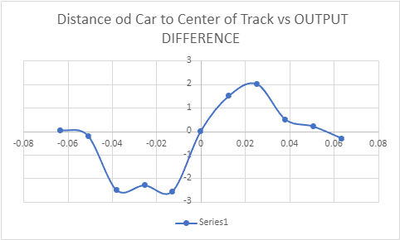
Figure 5. Graph of the Distance of Car to Center of Track vs OUTPUT DEFFERENCE of each sensor.

It's important to note some discrepancies between the voltage peaks for the two inductors. These discrepancies could be due to a variety of factors, such as slight variations in the construction of the inductors, inconsistencies in wire winding, or minor elevation differences from the ground. Although these discrepancies were present, they did not significantly impact the experiment's overall integrity.
Potential sources of error in our experiment include the inductors' elevation from the ground, which was only 1 cm, as well as their alignment relative to each other. Surface irregularities could affect the strength of the magnetic field at the inductor and any misalignment could lead to inconsistencies in our data. Additionally, we did not account for ambient magnetic fields or electrical noise, which could introduce extraneous variables into our experiment.
To mitigate these issues, several approaches could be considered for future work. For example, periodic calibration could be carried out for more reliable data. Employing multi-point averaging around the observed peaks may also help in reducing the impact of any anomalies or outliers.

Conclusions
In this laboratory experiment, we delved into the realms of open-loop control systems and feedback sensors, specifically focusing on their applications in powering servo motors and distance measurement. The hands-on experience allowed us to deepen our understanding of control systems theory and its practical implementations.

Open-Loop Control
We successfully designed and implemented an open-loop control system for regulating a servo motor. Despite its inherent limitations, such as the lack of real-time feedback, the system performed reliably within the given specifications. We designed a regulation circuit and a voltage divider circuit to ensure that the servo motor operated within the safe voltage range of 4.8V to 6V. The microcontroller was programmed to read the output voltage from the voltage divider and calculate the PWM duty cycle accordingly. While the system displayed minor oscillatory behavior, we proposed the incorporation of a capacitor across the power bus to mitigate this issue. This capacitor would provide the necessary instantaneous current to stabilize the servo's operation, offering a straightforward yet effective solution.

Feedback Sensor and Distance Measurement
We also designed a sensor circuit for distance measurement, relying on inductors and op-amps. The circuit included stages for LC resonance, amplification, rectification, and low-pass filtering. Our tests revealed an effective operating range of approximately 10 cm for magnetic field detection, within which the sensor performance was notably consistent. Despite some discrepancies in voltage peaks between the two inductors, the overall functionality of the circuit remained largely unhampered. However, we identified potential sources of error, including elevation of the inductors from the ground and alignment issues, which could be addressed in future work.

Future Work and Recommendations
For future iterations of this lab, periodic calibration could ensure more accurate and reliable data. Additionally, multi-point averaging techniques could be employed to reduce the impact of any anomalies or outliers in the distance measurement data. It might also be beneficial to explore closed-loop control systems for a more adaptive and robust solution in future projects.

Overall Takeaways
The lab successfully met its educational objectives, providing us with a robust understanding of the principles underlying both open-loop control and feedback systems. The experience served as a valuable bridge between theoretical knowledge and real-world applications, preparing us for more advanced studies in control systems, sensor technologies, and their diverse applications in mechanical and electrical engineering.

Appendix

Screenshots at N1, N2, N3
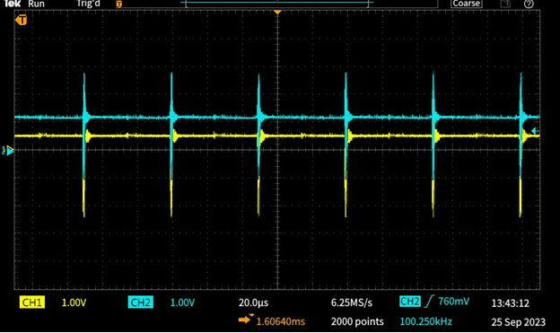
Figure 6. Signal at Node 1 (N1) of Feedback Sensor Circuit.

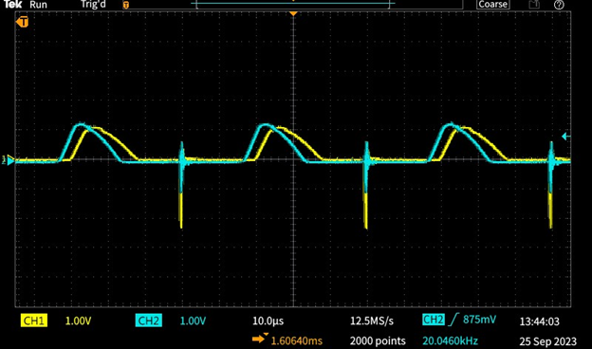
Figure 7. Signal at Node 2 (N2) of Feedback Sensor Circuit.

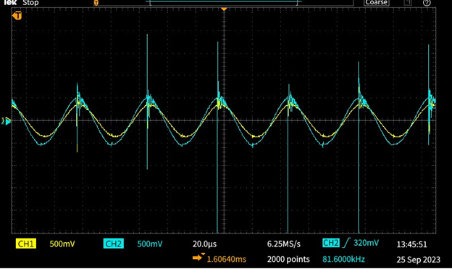
Figure 8. Signal at Node 3 (N3) of Feedback Sensor Circuit.

References
[1] Electronics Hub, "What is an Open Loop System? Examples, Advantages, Disadvantages," Electronics Hub, 2023. [Online]. Available: https://www.electronicshub.org/open-loop-system/ [Accessed: Sep. 29, 2023].
[2] "Understanding the Basics of Pulse Width Modulation (PWM) - Technical Articles," Control.com. [Online]. Available: https://www.control.com/technical-articles/understanding-the-basics-of-pulse-width-modulation-pwm/. [Accessed: September 30, 2023].
[3] “Servo Speed Regulation,” Kollmorgen, [Online]. Available:
https://www.kollmorgen.com/sites/default/files/public_downloads/Servo_Speed_Regulation_en-US.pdf. [Accessed: September 30, 2023].
[4] "Diode," Encyclopedia Britannica. [Online]. Available:
https://www.britannica.com/technology/diode. [Accessed: September 30, 2023].
[5] A. R. Hambley, Electronics, Second Edition, ISBN 0-13-691982-0, pp. 61-90.
[6] A. Parrell and J. Houde, "Modeling Sensory Feedback in Speech Production: A Tutorial," Signal Modeling and Analysis Group, University of Wisconsin, Madison, WI, USA, 2019. [Online]. Available:
https://smng.wisc.edu/wp-content/uploads/sites/354/2021/02/Parrell_Houde2019_ModelingSensoryFeedback.pdf. [Accessed: September 30, 2023].

